Security And Monitoring
- Virus Total:
Determine the suspicions file
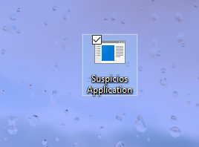
Preforming application assessment scan using a security scanning tool called virus total
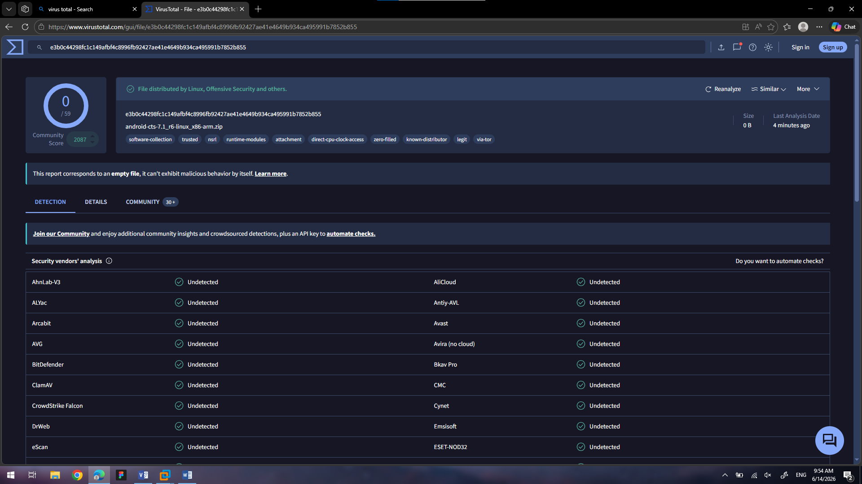
Analyzing the scan results and identifying potential risks.
No Potential Risks Found
Deciding whether the application is suspicious or save.
The File Is Save

- Encryption And Decryption
Identify Critical File
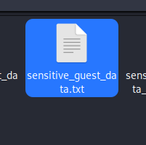
Apply Symmetrical Encryption
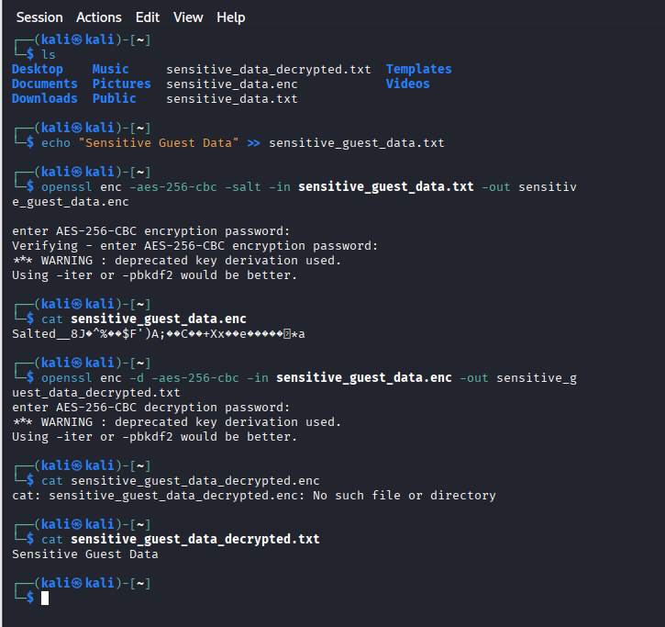
Write Encryption Commands
Enc:
openssl enc -aes-256-cbc -salt -in sensitive_data.txt -out sensitive_data.enc
Dec:
openssl enc -d -aes-256-cbc -in sensitive_data.enc -out sensitive_data_decrypted.txt

